

ONLINE ISSN: 2188-9023 PRINT ISSN: 0919-2948

Volume **, Number *, Page ***-*** [ determined after the paper acceptance ]

Category: Paper [Select the category: Paper, Translated Paper, Note, Translated Note ]

Received date: Date, Month, Year [ determined by Paper review committee ]

Accepted date: Date, Month, Year [ determined by Paper review committee ]

Advance publication date: Date, Month, Year [JSDE fills in]

Publication date: Date, Month, Year [JSDE fills in]

Corresponding author: Taro SEKKEI (E-mail address: ****@*****)

DOI: **.****/J.JSDE. 2015******* [ determined by Publication committee ]

Copyright©2015 Japan Society for Design Engineering

**Author’s Guide for JSDE**

**(Format for Manuscript of JSDE)**

John SMITH*1, Hanako SEIZU*2, and Jiro KOUGAKU*3

**Abstract**

The length of the abstract is almost 200 words. The indent is not needed. Do not start a new paragraph. Do not refer the figure, table, and equation. If necessary, show the equation itself. * * * * * * * * * * * * * * * * * * * * * * * * * * * * * * * * * * * * * * * * * * * * * * * * * * * * * * * * * * * * * * * * * * * * * * * * * * * * * * * * * * * * * * * * * * * * * * * * * * * * * * * * * * * * * * * * * * * * * * * * * * * * * * * * * * * * * * * * * * * * * * * * * * * * * * * * * * * * * * * * * * * * * * * * * * * * * * * * * * * * * * * * * * * * * * * * * * * * * * * * * * * * * * * * * * * * * * * * * * * * * * * * * * * * * * * * * * * * * * * * * * * * * * * * * * * * * * * * * * * * * * * * * * * * * * * * * * * * * * * * * * * * * * * * * * * * * * * * * * * * * * * * * * * * * * * * * * * * * * * * * * * * * * * * * * * * * * * * * * * * * * * * * * * * * * * * * * * * * * * * * * * * * * * * *

**Key words**

design, self-excited system, vibration (Select 5 to 10 words)

John Smith, Hanako SEIZU, and Jiro KOUGAKU, A Study on *****, Proceedings on the 3rd International Conference on Design Engineering and Science (ICDES2014), JSDE, (2014), pp.**-**, ( ** July 2013, accepted). [ if this paper has been published by the proceedings. ]

John Smith, Hanako SEIZU, and Jiro KOUGAKU, A Study on *****, Journal of “Design Engineering”, JSDE, (2014), pp.**-**, ( ** July 2013, accepted). [ if this paper is the translated paper ]

*1 Member, Dept. of Mechanical Engineering, University of Nippon Sekkei (2-22-17 Hyakunin-cyo Shinjuku, Tokyo XXX-YYYY, JAPAN), Taro.SEKKEI@jsde.or.jp

*2 Student Member, Dept. of Mechanical Engineering, University of Nippon Sekkei (same as above), hanako.SEIZU@jsde.or.jp

*3 Nonmember, Design department, Seizu Ltd. (1-2-3 Cad-cyo Chiyoda, Tokyo XXX-YYYY, JAPAN), Jiro.KOUGAKU@jsde.or.jp

**1 Introduction**

Authors prepare the manuscript based on this author’s guide. The manuscript is in single column format on A4 (210mm*297mm). The standard paper is from 6 to 10 pages (only even pages). Do not exceed 16 pages. The margins, the top, the bottom, and the right and left, are 29mm, 28mm, and 20.5mm, respectively. The bold Arial fonts of 14pt for the paper title, the bold Arial fonts of 12pt for the author names and the section headings, and the proportional Times New Roman of 10pt for the main text are recommended. The paper title and author name are centered. The space between lines is 15pt. Special terms should be marked with superscript numerals*4 with a note at the bottom of the page.

We have four categories for paper submission: Paper, Translated Paper, Note, and Translated Note. Please visit the submission rule for J-STAGE: http://www.jsde.or.jp/japanese/index.html

**1.1 Section Headings**

Section headings are left justified and requires the blank lines above and below. Sub-section headings are numbered 1.1, 1.2 etc. and requires a blank line above. The author can also use (a) and (b) or (1) and (2) as sub-subsection.

**2 Figures and Tables**

Figures and tables must be numbered consecutively and require the blank lines above and below. The figure number and caption are typed below the illustration and centered. The table number and caption are typed above the table and centered. These are the Arial font of 10pt. The captions in the figure and table are recommended larger than 8pt. The resolution of the picture is recommended over 600DPI. Note that the figure and table should be embedded in the defined margin. Figure 1 presents an example. The other examples are shown in Fig.2 and Table 1. Please use Arial for the citation of the figure and table.

The SI unit is recommended. Use the upright type for the unit and the italic type for the symbol and variables, for example, 1.78*k*, 6.01kN, and 1.6*10-6m.

All references should be listed and numbered at the end of the paper. When citing references in the text, type the corresponding number in square brackets as shown at the end of this sentence [1], [3], and [9]. Avoid using the temporary Web site and the local language journals.



**Fig. 1 An example of \*\*\*\*\***

*4 The explanatory footnote should be given consecutive number from the author’s number (*3, etc.).

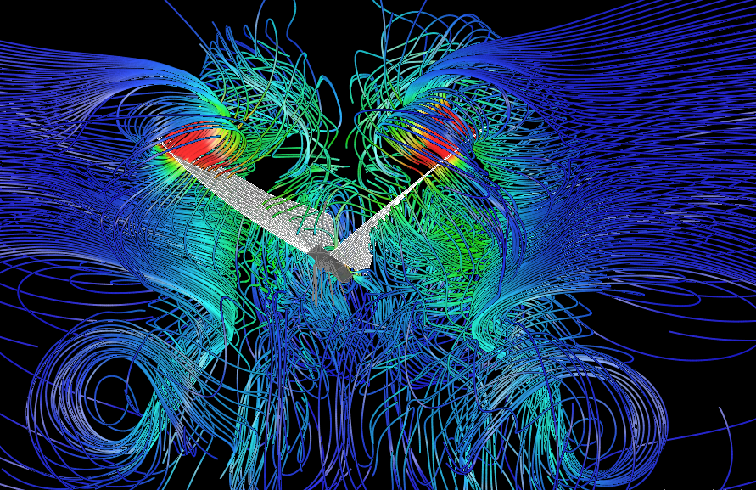

**Fig. 2 An example of *****10)**

**Table 1 Experimental results**

|  |  |  |  |
| --- | --- | --- | --- |
|  | Length [m] | Vibration [Hz] | Force [N] |
| Case A | 0.114 | 26.3 | 1.21*10-2 |
| Case B | 0.158 | 21.6 | 3.01*10-2 |
| Case C | 0.206 | 19.2 | 6.22*10-2 |

**3 Equations**

The equation requires the indent, the consecutive number, and the blank lines above and below.

 (1)

subject to

 (2)

where *b* is a ABC parameter [kN]. The fraction such as Eq.(2) is typed as *b*＝*d*(*e*＋*f*)/(*g*＋*h*) in main text.

**4 Conclusions**

We receive your manuscript (PDF file less than 3 Mbytes), via E-mail: toukou@jsde.or.jp. You can check the review process through http://www.jsde.or.jp/shuppan/progress.htm.

We may ask the authors the modification of the figure and table layout in some cases.

The Japan Society for Design Engineering (JSDE) are looking forward to receiving your paper.

**References**

1) James, A. and Sato, B.: Design Methodology, Journal of Design Engineering, 50, 8 (2015), 563.

2) ……

3) Lang, L.: Theory and Application for Mechanical Design, MIT press, (2005), 236.

4) Douglas, A.E.: Introduction of Mechanical Design, New York Pub. Co., (1993), 53.

．．．

10) Sekkei, H.: Design Engineering for ABC, Design Engineering, JSDE, 50, 1 (2014), 520.   
(online), available from <https://www.jstage.jst.go.jp/article/jjsde/49/1/49_30/****.pdf> , (accessed 2014-01-21).

11) Sekkei, T., Anderson, O., Sima, H.: A Study on Control Mechanism for …, The 3rd International Conference on Design Engineering and Science (ICDES2014), (2014), 634.